Leaving Cert.
Applied Maths
Revision guide q1-5

Question 1 – Linear acceleration | Past Exam Questions
- Constant uniform acceleration | 2013a,
- Time-speed graphs | 2013b
- Problems involving two particles | 2014a, 2012a
- Newton’s laws | 2014b,
Question 2 – Relative Velocity
- Problems involving two particles | 2014 a, 2014b, 2013b
- Road junctions | 2013a,
- Rivers, currents and winds

- Apparent velocity of wind
Question 3 – Projectiles
- Projectiles on a horizontal plane | 2014a, 2013a
- Hitting a target
- Projectiles on an inclined plane | 2014b, 2013b
- Projectiles which bounce
Question 4 – Pulleys and wedges
- Particles with pulleys | 2013b
- Particles on rough surfaces | 2014a,
- Relative accelerations | 2013a,
- Wedges | 2014b,
Question 5 – Impacts Collisions
- Direct impacts | 2013b,
- Oblique impacts

- Direct collisions | 2014a, 2013a,
- Oblique collisions | 2014b

Q1 Uniform linear acceleration

This topic is about particles which move in a straight line and accelerate uniformly. Problems can vary enormously, so you have to have your wits about you. Problems can be broken down into three main categories:
- Constant uniform acceleration
- Time-speed graphs
- Problems involving two particles

- Constant uniform acceleration:
Remember what the following variables represent:
t = the time ;
a = the acceleration;
u = the initial speed ;
v = the final speed ;
s = the displacement from where the particle started.

When the acceleration is negative, it is sometimes called a deceleration or retardation. For example, an acceleration of –3 ms⁻² is the same as a deceleration (or retardation) of 3 ms⁻².
• To answer this question, you will need to use the four key formulae intelligently.
They are: 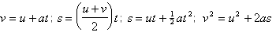
• It is important to know the second of these equations off by heart although all but the second appear on Page 40 of The Mathematical Tables. Secondly, you may be asked to derive either of the last two equations from the first two. Practise this.
• These four formulae will be useful elsewhere (for example when doing Questions 3 and 4 on projectiles and connected particles).
2.Time-speed graphs
Remember that the above formulae may be used only while the acceleration is uniform. If a particle speeds up, but then travels at a constant speed, and then slows down, the above formulae cannot be used for the entire journey. In these cases we solve the problem by drawing a time-speed graph, with time as the horizontal axis.
There are four key points to remember about time-speed graphs:
• The area between the graph and the time-axis represents the distance travelled.
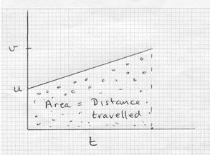
• The slope of the graph represents the acceleration.
• If a particle starts from rest, then v = at [i.e. the final speed will be the product of the acceleration and the time.] rise = slope x run
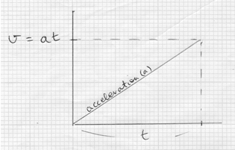
• If a particle accelerates from rest for time t₁ with acceleration a and immediately decelerates to rest in time t₂ with deceleration d, then t₁:t₂ = d:a
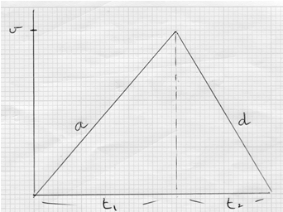
For example, if the acceleration is 6 ms⁻² and the deceleration is 8 ms⁻², then t₁:t₂ = d:a = 8:6 = 4:3 . It follows that of the time will be spent accelerating and of the time will be spent decelerating.
3. Problems involving two particles
• If particles P and Q set off together and later overtake each other, then overtaking will occur when S_{p} = S_{q} . If, however, P was 25 metres behind Q at the start, then when overtaking occurs,
S_{p} = S_{q} + 25
• If P and Q are a distance l apart and move towards each other, they will meet when S_{p} + S_{q} = l
• The greatest gap between particles P and Q occurs when v_{p} = v_{q} (because if their speeds are unequal then the gap is either increasing or decreasing)
• If particle A sets out and, two seconds later, particle B sets out in pursuit, then let t = the time which A spends on the road and t - 2 = the time which B spends on the road. (Students will often put t + 2 instead of t - 2.)
Common mistakes
Common mistakes made in doing this question are:
• Assuming that the particle starts from rest, even though this is not stated in the question.
• Using the formulae where they do not apply.
• Jumping into the question before giving it enough clear thought. (draw a diagram)
• Not drawing a clear time-speed graph.
• Letting u represent the speed at two different moments. For example, if a particle travels from a to b, a distance of 30 m in 4 seconds and then travels from b to c, a distance of 54 m in a further 3 seconds - how would you find the acceleration? You let u = the speed of the particle at a (not anywhere else!). Then you form an equation for the journey [ab] and another for the journey [ac] . These equations will be (using s = ut +½at²) : 30 = u(4) +½a(16) and 84 = u(7)+½a(49) . You solve these simultaneous equations to find a. NB: You do not form an equation for [bc], as the initial speed will not be the same u as in the first equation.
Q2 Relative Velocity
This topic involves looking at the world from a different perspective. We are used to the idea of observing, say, two ships as they sail the seas. This way of looking down from above (like Zeus looking down from Mount Olympus) is sometimes called the Olympian View.
When we study relative velocity, we see life differently. We go on board one of the ships. We observe the other ship, as seen from our ship. The origin is no longer fixed, but moves wherever our ship moves. Looking at the situation in this way makes difficult problems easy to solve.
There are four main types of question:
- Problems involving two particles
- Road junctions
- Rivers, currents and winds
- Apparent velocity of wind
- Problems involving two particles
The key formula is v_{ab}=v_{a} -v_{b} , where v_{ab} means the velocity of A as observed by B (i.e. the velocity of A relative to B).
• To answer this question, you must get away from thinking of problems from the Olympian view and get accustomed to looking at problems relatively. It takes time and practice - be patient.
• Draw plenty of diagrams - and make them clear, large and reasonably accurate. You might start with a diagram in the Olympian view and then move to a relative velocity diagram.
• If you are told that a car is travelling at 30 km/h in a direction 20º North of West, you must learn how to convert this velocity into a vector in terms of and . Draw a diagram, and then use your Junior Cert Trigonometry to get the correct answer: it is km/h.
• You also need to be able to do this process in reverse. Given, say, $v_{ab}=20i+10j$, can you find the speed and direction of the particle. Again draw a diagram.
The speed $=\sqrt{{20}^{2}+{10}^{2}}=22.36$ m/s and the direction is $\tan^{-1}\left(\frac{10}{20}\right)$ =26.565º North of East.
• The most common question asked is “Find the shortest distance between the particles”. Find the velocity of A relative to B; draw a diagram; show where B is (B stays still, since wherever B goes, the origin goes) ; now show the path of A relative to B ; the shortest distance (d) is found by drawing a straight line from B, perpendicular to the relative path of A.
• If you are asked to find for how long are the particles within a certain range of each other, draw a circle around B and find the length of the chord (see diagram) using Pythagoras’ Theorem. The time taken will be got by $t=\frac{distance}{time}$
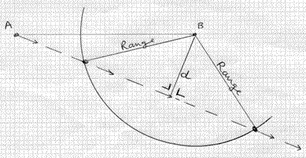
- Road junctions
For example let’s say you are given the diagram below and asked what is the shortest distance between A and B in subsequent motion. It seems a very difficult problem. But what will happen if you wait 8 seconds until A is at the junction? Now here is the new situation and the problem is much easier. It can be solved using the steps outlined above.
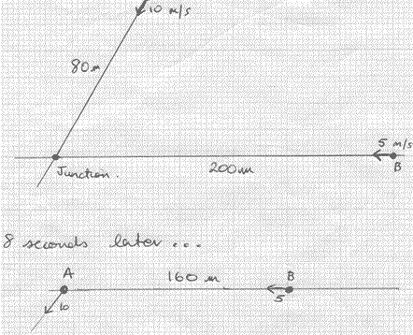
- Rivers, currents and winds
If a river is, for example, 60 metres wide and flows with speed 3 m/s. Let’s suppose your boat can go at 5 m/s, then remember the two key strategies:
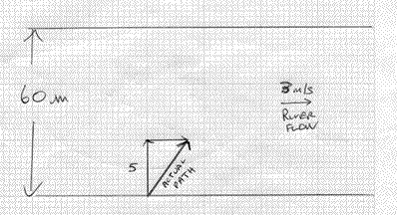
• To cross the river as quickly as possible, head straight across. Every second your boat will be 5 metres closer to the other side, so the time taken will be $\frac{60}{5}=12 s$
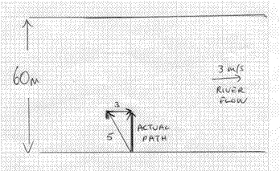
• To cross the river by the shortest path, head upstream, so that you end up going straight across. By Pythagoras’ Theorem, you will find that each second brings you 4 m closer to the opposite bank. The time taken will be $\frac{60}{4}=15 s$
- Apparent velocity of wind
The actual velocity of the wind and the apparent velocity of the wind are two different things. For example, if you are running at 5 m/s and there is a wind straight in your face of 2 m/s, then the wind appears to you to have a velocity of 7 m/s.
In these problems, let the velocity of the wind be . Write down the given velocity of the person, v_{p}, and find the velocity of the wind relative to the person (how the wind appears to the person), using the formula v_{wp} = v_{w} - v_{p}.
Now, if the apparent velocity is from the east or west, the j-component must equal zero.
If the apparent velocity is from the north or south, the i-component must equal zero.
If the apparent velocity is from the SW or NE, the i-component must be equal to the j-component.
If the apparent velocity is from the SE or NW, the i-component must be equal but of opposite sign to the j-component.
Manufacture the appropriate simultaneous equations and solve.
Common Mistakes
• Mixing up the Olympian View with the Relative View.
• Not drawing an appropriate diagram of the relative path.
• Inability to convert a given vector into i-j form.
• Confusing the actual velocity of the wind with the apparent velocity of the wind.
Q3 Projectiles

This topic is about objects which travel through the air under gravity. We analyse the problems by separating the x-direction (or i-direction) from the y-direction (or j-direction). It is important to distinguish between two very different vectors: the first is the position vector, which describes where the particle is at any time; the other is the velocity vector which describes the motion of the particle wherever it is. We are not interested in how the particle came to be flying through the air, we just want to know where the particle is and at what velocity is it travelling as it moves.
There are four main types of problem:
- Projectiles on a horizontal plane
- Hitting a target
- Projectiles on an inclined plane
- Projectiles which bounce
1. Projectiles on a horizontal plane
If the particle is projected on a horizontal plane with initial speed u at an angle $∝$ to the plane, then its velocity and displacement in each direction will be:
$$Type equation here.$$
$v_{x}=u\cos{∝}$ and $v_{y}=u\sin{∝}$
$s_{x}=u\cos{∝}t$ and $s_{y}=u\sin{∝t-\frac{1}{2}gt^{2}}$
• If you want to find the ‘time of flight’, find t when S_{y} = 0
• If you want to find when the particle reaches its highest point, find t when v_{y} = 0
• If you want to find the range, find S_{x} when S_{y} = 0 .
The general equation for the range is $R=\frac{u^{2}\sin{2∝}}{g}$. If you use this formula you must first derive it. Don’t produce it out of a hat!
• If you want to find the maximum height, find S_{y} when v_{y} = 0 [The quickest way is to use the formula v² = u² + 2as ] The general equation for the maximum height is $H=\frac{u^{2}\sin^{2}{∝}}{g}$. Again, show how to get this formula before you use it.
• A common question is to find the angle which gives maximum range and to find that range.
The answer is which yields a range of $\frac{u^{2}}{g}$ .
2. Hitting a target
If the particle hits a target at the point (a , b), the you must solve the simultaneous equations:
$u\cos{∝}t=a$ when $b=u\sin{∝t-\frac{1}{2}gt^{2}}$ .
The method is always the same:
• Let $t=\frac{a}{u\cos{ ∝}}$
• Substitute this expression for t in the second equation.
• Change $\tan{α}={\frac{\sin{∝}}{cos ∝}}$ and $\frac{1}{\cos^{2}{∝} }=1+\tan^{2}{∝}$ to get a quadratic equation in $\tan{α}$
• Solve the quadratic equation!

Note, if the particle ‘just clears a wall’ the technique is just the same as if the particle hits a target at the top of the wall. Use the same steps as above.

3. Projectiles on the inclined plane (leave till final year)
The key thing here is to let the inclined plane be the x-axis (or the i-axis).
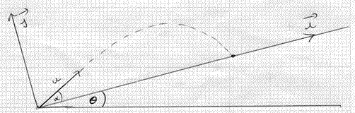
If the projectile is projected at an angle $∝$ to the plane, which is itself inclined at an angle to the horizontal, then the four key equations will be:
$v_{x}=u\cos{∝-g\sin{θ}t}$ and $v_{y}=u\sin{∝-g\cos{θ}}t$
$s_{x}=u\cos{∝t-\frac{1}{2}g\sin{θ}t^{2}}$ and $s_{y}=u\sin{∝t-\frac{1}{2}g\cos{θ}t^{2}}$
(If the particle travels down the plane, the equations will be as above, except with a plus instead of a minus in the equations for v_{x} and S_{x} )
• To find the range along the plane, find S_{x} when S_{y} = 0
• To find the maximum perpendicular height above the plane, find S_{y} when v_{y} = 0
• If the particle lands perpendicularly to the plane, then v_{x} = 0 when S_{y} = 0
• The landing angle (l) is given by $\tan{l=v_{y}/v_{x}}$ when S_{y} = 0
• If the particle lands while travelling in a horizontal direction, then $\tan{θ=v_{y}/v_{x}}$ when S_{y} = 0 (since the landing angle and the angle of the hill will be the same)
4. Projectiles which bounce
The first step is to find v_{x} and v_{y} for the moment when the particle lands from the first ‘flight’. As the particle takes off on its second flight, the initial velocities will be given by
u_{x} = v_{x} (from first flight) and u_{y} = (-e)v_{y} (from first flight). Now proceed as before.
Common Mistakes
• Lack of basic trigonometry. E.g. how do you find two viable solutions to the equation$\sin{2∝=\frac{1}{2}}$ ? (The answers are 15º and 75º-if you can’t get this see me)
• Mixing up $∝$ and $θ$ .
• Lack of familiarity with the formulae on Page 9 of the Mathematical Tables

- Connected Particles: Pulleys & Wedges
This topic is about objects which are connected by strings, or which travel across surfaces (both smooth and rough). It also involves wedges. The key thing to remember is the formula F = ma. In this equation, F represents the total force along the line in which the particle travels; m is the mass ; a is the acceleration of the particle.
There are four main types of question:
- Particles with pulleys
- Particles on rough surfaces
- Relative accelerations
- Wedges
1. Particles with pulleys
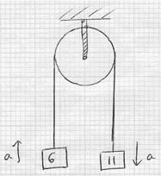
Always draw separate diagrams for each particle, showing the forces as vectors. Show the acceleration of each particle nearby. It is a bad habit to put the vectors for the acceleration and the forces on the same diagram.
Here are the separate diagrams for the above two particles:
The equations of motion will be : T - 6g = 6a and 11g - T = 11a. Note how the direction in which the particle will travel determines the positive direction for the forces. These simultaneous equations can now be solved. Make the positive direction the direction for the Forces acting on a body the same as the positive direction of the acceleration.
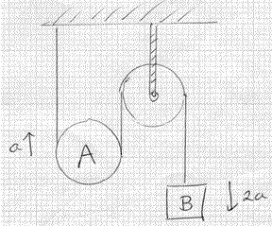
In this case, if particle A travels up 1 metre, then particle B will travel down 2 metres. It follows that if a = the acceleration of A, then 2a = the acceleration of B.
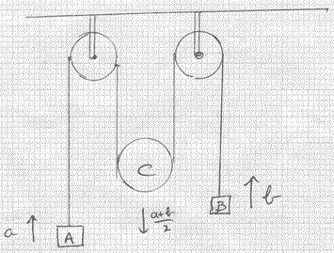
In this case, if particle A travels up (say) 3 metres, and particle B travels up (say) 11 metres, then moveable pulley C will travel down $\frac{3+11}{2}=7$ metres. It follows that if a = the acceleration of A, and b = the acceleration of B, then the acceleration of C will be $\frac{a+b}{2}$.
2. Particles on rough surfaces
When a particle travels along a rough surface, then friction is called into play. The amount of friction is determined by the equation $F=μR$ , where F is the friction, $μ$ is the coefficient of friction and R is the normal reaction. In each case (where there is friction) follow the three steps:
• Find the normal reaction
• Calculate the friction using $F=μR$
• Write down the equation of motion
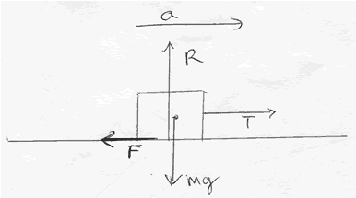
In this case:
$$R=mg$$
$F=μR=μmg$
• The equation of motion is: $T-μmg=ma$
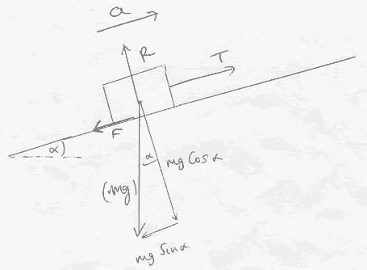
In this case:
• $R=mg\cos{α}$
•: $F=μmg\cos{α}$
• The equation of motion is: $T- μmg\cos{α-mg\sin{α}=ma}$ (note if the object was accelerating down the hill then the friction would be acting in the opposite direction.
3. Relative accelerations
Where moveable pulleys have particles attached, relative acceleration is called into play. This is like when you walk on a travelator. If the travelator has speed a and you walk with speed b relative to the travelator, your actual speed will be a + b. If, however you walk against the travelator, then your actual speed will be b - a.
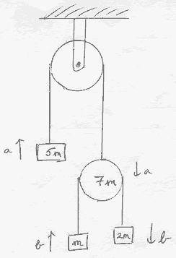
Note: there are two separate strings here. Let T be the tension in the top one and S the tension in the other one.
Let b be the acceleration of the particles m and 2m relative to the 7m pulley. The actual acceleration of the m mass will be b - a and that of the 2m mass will be a+ b.
The four equations of motion will be :
T - 5mg = 5ma ; 7mg + 2S - T = 7ma ; 2mg - S = 2m(a+b) ; S - mg = m(b-a)
4. Wedges
There is a difference between an inclined plane and a wedge. An inclined plane is fixed and will not move. A wedge is a sloped piece of wood which can move. It needs careful and special treatment.
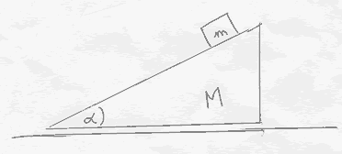
In the case of the particle which slides down the wedge, draw one diagram showing the forces of the particle, and another showing the accelerations. Then resolve all forces and accelerations into two directions: parallel to the face of the wedge and perpendicular to it. The latter diagram will include the acceleration, f, of the particle relative to the wedge and the acceleration, a, of the wedge itself. This is because, as the wedge moves, it will bring the particle along with it.
You get two equations for the particle:
The first is F = ma for the movement parallel to the face of the edge: .
The second is F = ma for the movement perpendicular to the wedge:
The equation for the wedge is much easier. There will be an equal but opposite reaction R at the particle. Resolve this. There is just one equation: .
These three equations can then be solved.
There are variations on this theme, where the table is rough, but if you know your basics, and practise enough questions, you will get used to the difficulties of such problems.
Common Mistakes
• Letting all accelerations be a, even though they may not be equal.
• Forgetting to put in relative accelerations when there are moveable pulleys.
• Mixing up inclined planes and wedges. Students who do this will write for their second wedge equation: $R=mg\cos{α}$ which is wrong.

5. Impacts & Collisions
This topic is about spheres which collide with a barrier (impacts) or which collide with another sphere (collisions). There are four main types of question:
- Direct impacts
- Oblique impacts
- Direct collisions
- Oblique collisions
1. Direct Impacts
The equation which governs all impacts is Newton’s Experimental Law (NEL):
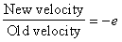
A particle (of mass 5 kg) falls vertically and hits the ground with speed, say, 40 m/s (i.e. its velocity vector is . If the coefficient of restitution e = 0.8, then
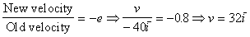
So the particle will rise with speed 32 m/s.
You must also know the definitions of impulse and kinetic energy. The symbol for impulse (a vector quantity, measured in Newton seconds) is I and is defined as :
In this case
The kinetic energy of a body (a scalar quantity measured in joules) is defined as K = ½mv². Loss in kinetic energy = ½mu²- ½mv² .
Hence, in our case, the loss in kinetic energy = ½(5)(40)² - ½(5)(32)² = 1440 joules
2. Oblique Impacts
A particle of mass 4 kg hits horizontal ground with velocity m/s. The coefficient of restitution e = 0.5. What will the new velocity be after impact?
The key thing here to understand is that the i-speed will not change, but only the j-speed is subject to Newton’s Experimental Law: 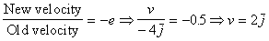
So the new speed will be m/s.
In this case,
It is worth noting that if the velocity of a particle is m/s, then its velocity v is determined by the equation v² = x² = y² (by Pythagoras’ Theorem) and hence, in this case, loss in K.E. = ½mu²- ½mv² = ½(4)[(3)²+(-4)²] - ½(4)[(3)²+(2)²] = 24 joules.
3. Direct Collisions
The two equations which govern all collisions are the
Law of Conservation of Momentum (COM): m₁u₁+m₂u₂ = m₁v₁+m₂v₂
Newton’s Experimental Law (NEL): 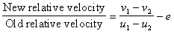
You solve the simultaneous equations to find the unknown final velocities v₁ and v₂.
4. Oblique Collisions
If we let the line of centres at impact be the i-axis, then the j-velocities will remain unchanged after the collision. Lets imagine this is the set-up:
Before collision (Mass) After Collision
First sphere m₁
Second sphere m₂
We want to find the unknowns x and y. We use the two simultaneous equations:
• COM: m₁a + m₂c = m₁x +m₂y
• NEL: 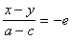
Solve these to get the answers.
There will be variations on this theme:
• If a sphere is at rest before impact, it will move along the i-axis after the collision.
• If the question states that before impact one of the spheres is at rest and that after impact, the spheres move at right angle to each other, then one sphere will move along the i-axis and the other along the j-axis.
• If you want to find the angle through which, for example, the second sphere above is deflected by the impact, follow these steps:
Find the slope of its path before = $m_{1}=\frac{d}{c}$
Find the slope of its path after = $m_{2}=\frac{d}{y}$
Find (the angle of deflection), using the formula .
$\tan{θ}=±$($m_{1}-m_{2})/(1+m_{1}m_{2})$

Common Mistakes
• Forgetting to put the minus in front of e in NEL.
• Applying NEL to both directions, not just to the direction of impact.
• Confusing momentum and kinetic energy.
• Forgetting the definition of impulse, even though it is on Page 40 of The Mathematical Tables!

